Experiment 1: Case Study
Problem Statement: Choose a real-world case study such as an E-Commerce System or KL ERP System, create user stories, select an appropriate software development process model, identify a suitable programming language, and propose an implementation and evaluation strategy.
Real-World case study on KL ERP system
1. Functional Requirements
Faculty
- Record attendance
- Upload course materials
- Enter marks
- Prepare assignments
- Check record books
- Manage experiments
- Track student performance

Administrator
- Manage student records
- Generate reports
- Update details
- Track status
- Process complaints
- Generate performance reports

2. User Stories
User ID | User Story | Priority
US-13 | As a faculty, I want to login securely. | High
US-14 | As a faculty, I want to view my timetable. | High
US-15 | As a faculty, I want to mark attendance. | High
US-16 | As a faculty, I want to upload marks. | High
US-17 | As a faculty, I want to upload study materials. | Medium
US-18 | As a faculty, I want to post assignments. | Medium
US-19 | As a faculty, I want to view student details. | Medium
US-20 | As a faculty, I want to send notifications. | Medium
US-21 | As a faculty, I want to view attendance reports. | Medium
US-22 | As an administrator, I want to login securely. | High
US-23 | As an administrator, I want to manage student accounts. | High
US-24 | As an administrator, I want to manage faculty accounts. | High
US-25 | As an administrator, I want to manage courses. | High
US-26 | As an administrator, I want to manage timetables. | High
US-27 | As an administrator, I want to manage attendance records. | Medium
US-28 | As an administrator, I want to manage examination schedules. | Medium
US-29 | As an administrator, I want to generate reports. | Medium
US-30 | As an administrator, I want to manage notifications. | Medium
3. Selected Software Development Process Model
Agile Scrum
Reason for Selection
- Requirements may change during development.
- Continuous feedback from faculty and administrators.
- Incremental feature delivery.
- Faster development cycles.
- Easy testing and bug fixing.
- Suitable for ERP web applications.
Sprint Plan
Sprint | Features
Sprint 1 | User Registration & Login
Sprint 2 | Product Catalog & Search
Sprint 3 | Shopping Cart
Sprint 4 | Order Processing
Sprint 5 | Payment Gateway
Sprint 6 | Admin Dashboard
Sprint 7 | Testing & Deployment

4. Programming Language Selection
Backend
- Java (Spring Boot)
Reasons
- Secure
- Scalable
- Enterprise-level applications
- REST API support
- Excellent database connectivity
Frontend
- HTML5
- CSS3
- JavaScript
- React.js
Database
- MySQL
Other Technologies
- REST API
- JWT Authentication
- Git
- Docker
- AWS Cloud

5. System Architecture
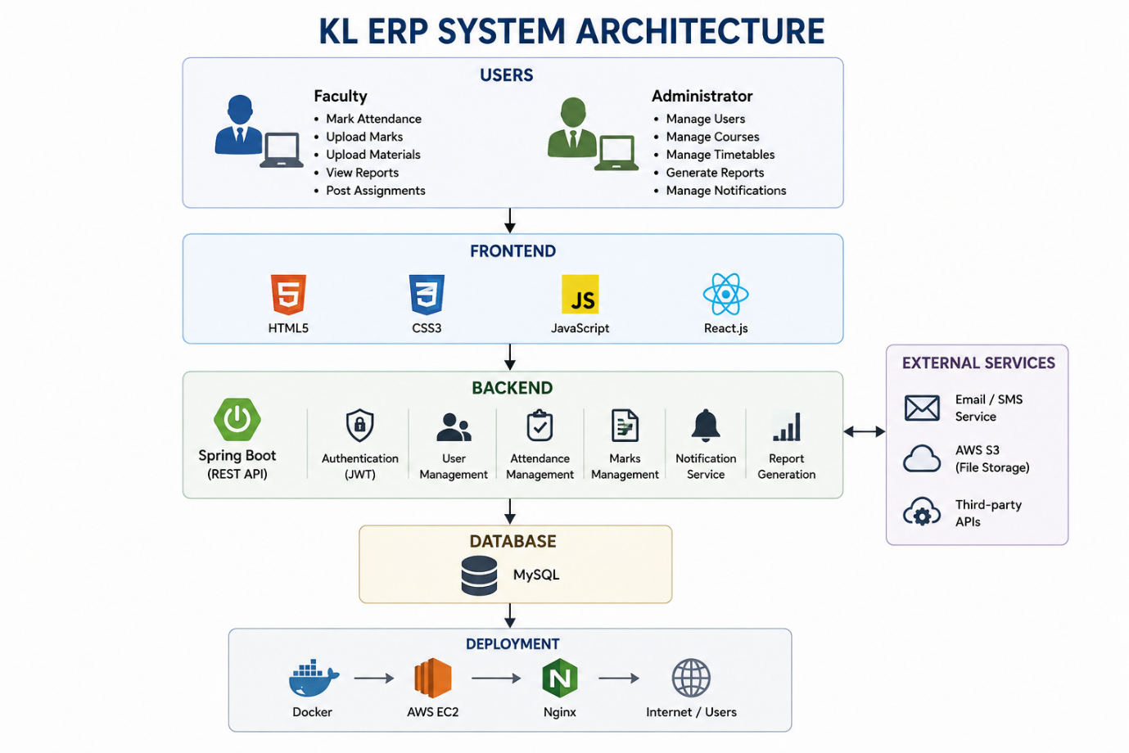

6. Implementation Strategy
Phase 1 – Requirement Analysis
- Gather faculty requirements.
- Gather administrator requirements.
- Prepare Software Requirement Specification (SRS).
- Create use case diagrams.

Phase 2 – System Design
- Design database schema.
- Design UI wireframes.
- Create UML diagrams.
- Design system architecture.

Phase 3 – Development
- Implement user authentication.
- Develop faculty dashboard.
- Develop attendance module.
- Develop marks management.
- Develop timetable module.
- Develop administrator dashboard.
- Implement notifications.

Phase 4 – Testing
Unit Testing
- Login
- Attendance
- Marks
- Timetable

Integration Testing
- Attendance + Database
- Marks + Reports
- Notifications + Users
System Testing
- Complete ERP testing
User Acceptance Testing (UAT)
- Verify faculty requirements.
- Verify administrator requirements.

Phase 5 – Deployment
- Docker Container
- AWS EC2
- MySQL Database
- Nginx Web Server

7. Evaluation Strategy
Evaluation Parameter | Method
Functional Accuracy | Requirement verification
Performance | Load testing using JMeter
Security | Authentication and penetration testing
Reliability | Continuous monitoring
Usability | User feedback survey
Scalability | Concurrent user testing
Maintainability | Code review and documentation

8. Expected Outcomes
- Secure ERP login system.
- Easy attendance management.
- Accurate marks management.
- Efficient timetable management.
- Fast report generation.
- Improved faculty productivity.
- Efficient administrator management.
- Scalable architecture for future enhancements.

